7 PM website

SETUP GUIDE

A search for the connoisseurs of world ……

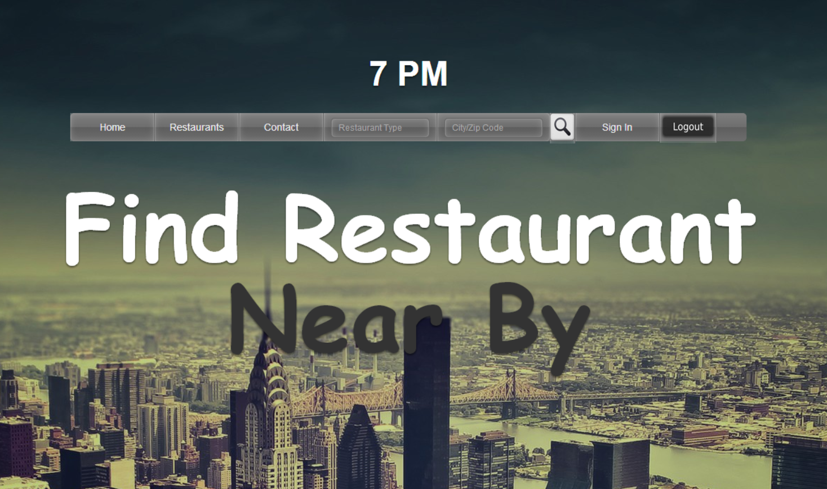

* 7 PM project need eclipse which can be downloaded from :<https://www.eclipse.org/downloads/>
* Local server environment is needed for which we used TOMEE can be downloaded from <http://tomee.apache.org/downloads.html>

Note: If you already have TomEE setup then escape the following part

------------------------------------------------------------------------------------------------------------------------------------------

**TOMEE setup**

1. Build a local server environment.

Step 1: Install Apache TomEE

1. Apache TomEE is a Tomcat server with a number of pre-packed libraries to enhance the basic capabilities of Tomcat. The term “TomEE” refers to the notion of enhancing Tomcat so that it is a compliant Java EE container like WebSphere or JBoss. JSTL, JAX-RS, JPA, and JSON data marshalling are a sample of the capabilities provided.
2. Apache TomEE can be downloaded here: <http://tomee.apache.org/downloads.html>.
   1. Version 1.6.0 was the latest production version at the time of this writing.
   2. Make sure to download the **JAX-RS** variety.
   3. The ZIP file can be extract to any directory. In the example below I extracted it to the root of my C: drive.

Step 2: Integrate Eclipse JEE with TomEE

1. The following instructions assume that you already have a Tomcat server defined in your Eclipse EE workspace.
2. Open the Window 🡪 Preferences menu and go to the Servers 🡪 Runtime Environments page.

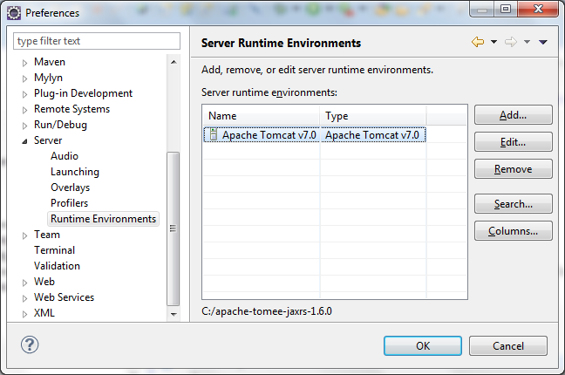

1. Add a new Tomcat server runtime. Set the path of the server runtime to the extracted TomEE directory. Edit the server runtime name with a “TomEE” identifier so that you can differentiate it from the standard Tomcat server runtime.

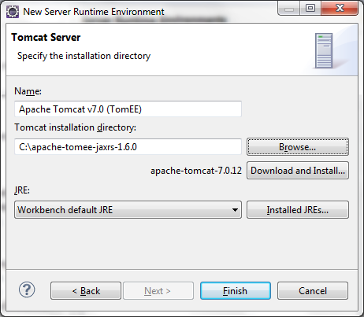

Step 3: Create a TomEE server reference

* 1. Switch to the Web perspective.
  2. Right-click in the servers window pane and create a new server.
  3. Choose Tomcat 7.0 and select your newly created TomEE runtime.

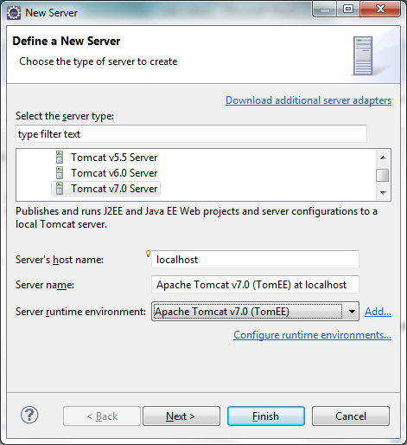

1. Create a JAX-RS web service

Step 1: Create a new Dynamic Web Project

1. Switch to the Web perspective.
2. Right-click in the Project Explorer window pane and choose new Dynamic Web Project.
3. Name your project “Catalog” or something similar.
4. Choose the Apache Tomcat v7.0 (TomEE) runtime. Accept all of the default project settings.

Step 2: Add the RESTful web service source code

1. Unzip the “Lab 2 Source Code.zip” file and copy the “edu.ilstu.it353” package and all of the Java source files to your project’s source code directory.

Step 3: Install the Project to TomEE

1. Right-click on the TomEE server reference and choose Add and Remove…
2. Move your project to the Configured window pane and click Finish.

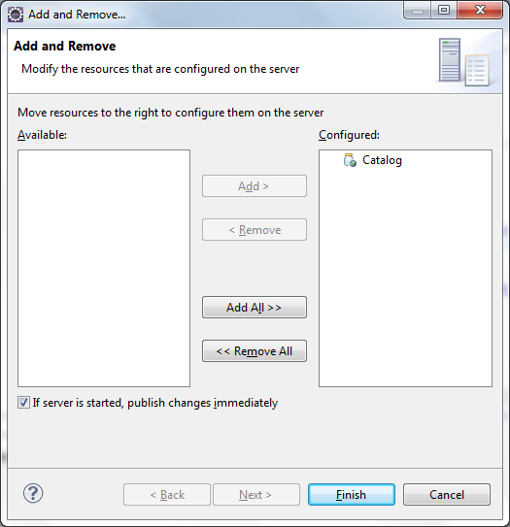

1. Start the TomEE server.

------------------------------------------------------------------------------------------------------------------------------------------

* Include the .jar libraries from lib folder in project’s java build path
  + Apache-tomee librarie
  + javax.ws.rs-api-2.0
  + mailapi
  + jackson-mapper-asl-1.9.13
  + mysql-connector-java-5.0.8-bin
* DATABASE MySql setup

1. Unzip both the MySQL folders and place it to your safe drives

* mysql-5.6.17-winx64 (download at http://my.ilstu.edu/~atjulia/mysql-5.6.17-winx64.zip
* mysql-connector-java-5.0.8

1. place connector library in TOMEE SERVER’s library folder
   1. mysql-connector-java-5.0.8-bin
2. Go to folder: mysql-5.6.17-winx64\bin

Run two executable sequentially files for starting MySQL database server

1. mysqld.exe
2. mysql.exe

NOTE: Always have to start MySQL server before starting the application

1. Now when MySQL server is running, install the MySQL front-end as SQLyog-11.4.2-0.x64Trial (30 days trial) for first time and run app with default settings

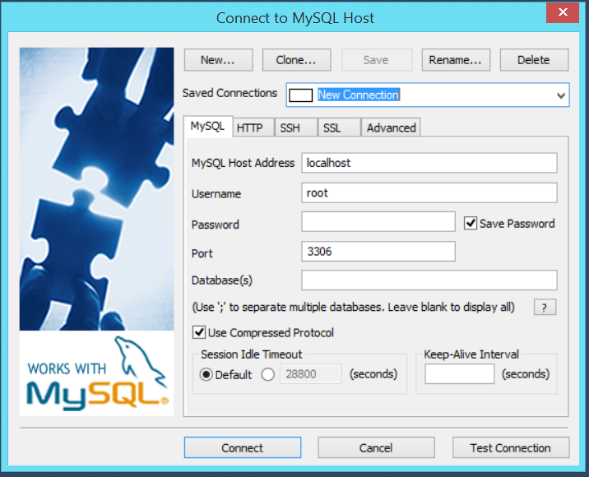

1. Create New Connection by Clicking on “New” button, take default **“New Connection”**
2. Click Connect
3. Create New database as **“m2db”**
4. Paste the Script from Script.txt in project to Query builder and Execute query (F9) which builds the students table with some data

**Go to eclipse**

1. Start TomEE server
2. Run Default.html from WebContent folder on server

Contact us for any questions on the project:

Gauravgaikwad777@gmail.com